IFCONFIG:
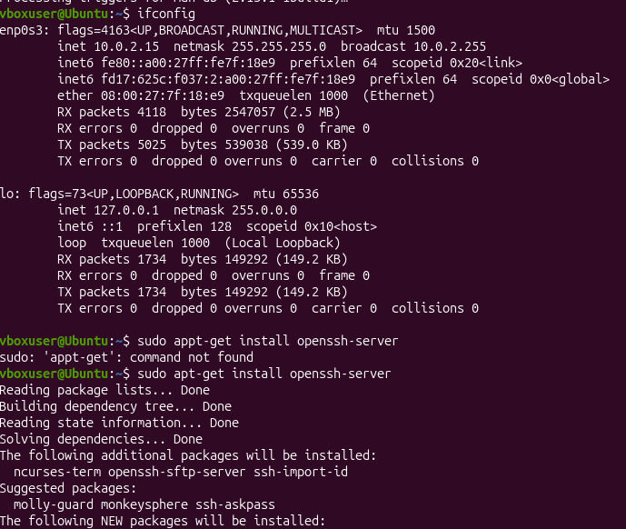
WE CAN SHARE THE FILE BETWEEN DIFFERENT SYSTEM AND WE CAN USE THE TOOLS LIKE SCP TO TRANFER THE FILE BETWEEN DIFFERENT TOOLS ALSO

